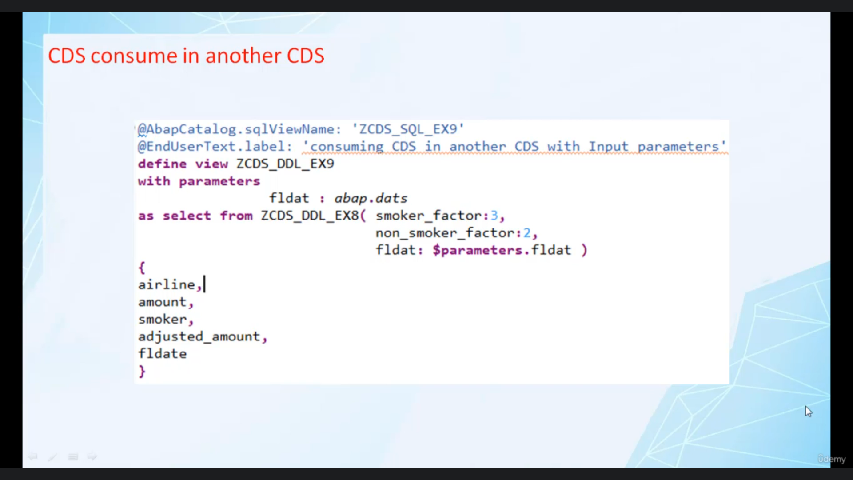

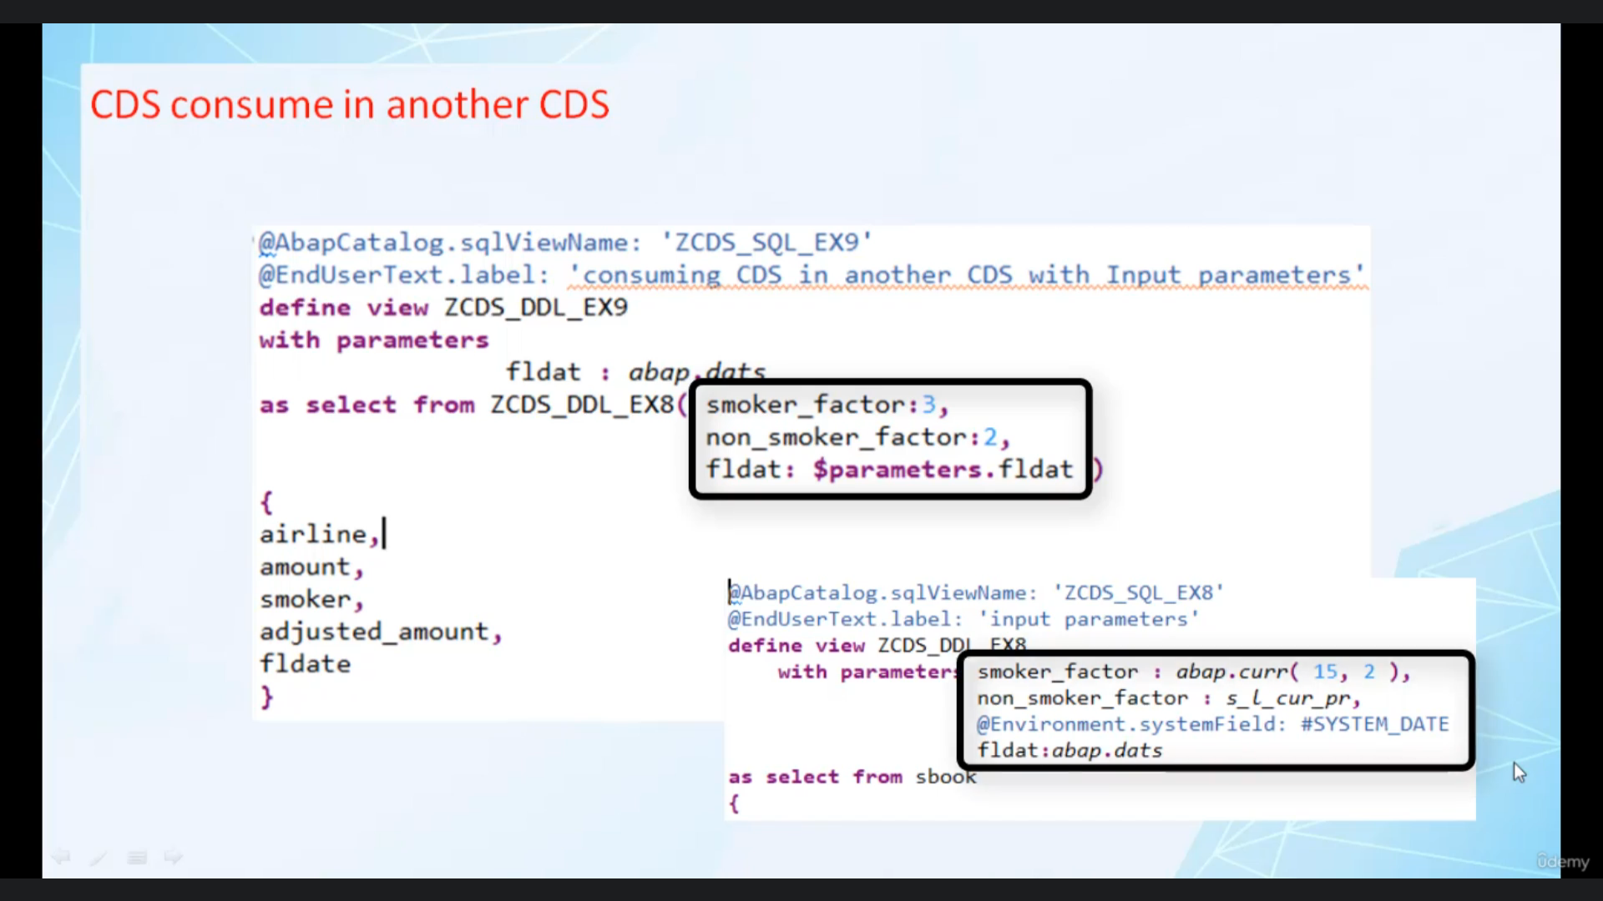

Hi, welcome back.

And this video, I will tell you how you can consume one Abbasids view in another Abbotsleigh through.

When I see this, we will from another series that has an input parameters, in that case, all the

input parameters have to be supplied with actual values.

This is done within in parenthesis immediately after the name of Susanville in from clothes, you also

have to remember all the parameters have to be supplied and they have to be in the same order as in

definition of the looks great when absurdism to consume one is in another few.